**Date:** 11 October 2025

**Location:** Aptech Pakistan

**Instructor:** Sir Hafizullah Khokhar

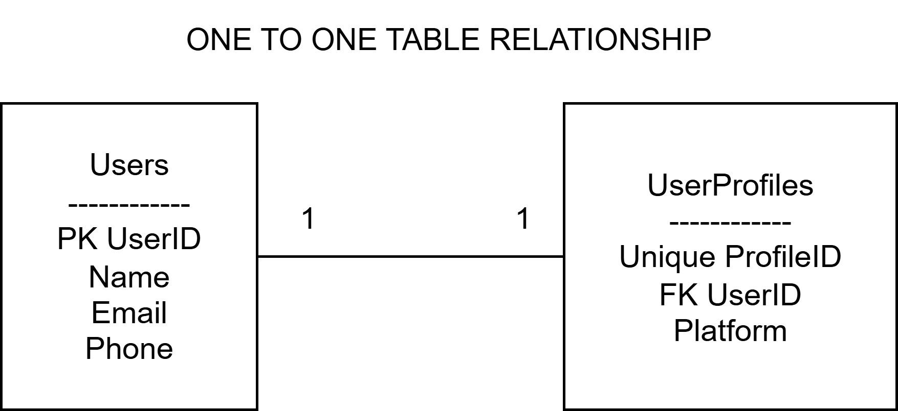

This ER Diagram shows a **One to One Relationship** between two tables **Users** and **UserProfiles**.

* Each **User** has only **one UserProfile**.
* Each **UserProfile** belongs to only **one User**.
* **UserID** is the **Primary Key** in the Users table.
* **UserID** is also the **Foreign Key** in the UserProfiles table.
* The line between them is labeled **1..1** which means One to One.